First, turn type arc suppression coil grounding compensation device Product introduction: turn type arc suppression coil is the use of on-load regulator switch to adjust the tap of the reactor to change the inductance value. When the power grid is running normally, the current amplitude of the current flowing through the arc suppression coil is measured in real time to calculate the current capacitance to the ground of the power grid under the current mode. According to the preset minimum residual current value, the controller adjusts the on-load voltage regulating tap to the required compensation gear. When the ground fault occurs, the capacitor current at the ground is compensated, so that the residual current at the fault point can be limited within the set range.   
Product features: Simple structure, easy operation, low noise; Automatically track changes in the way the grid operates. Ground compensation time to achieve zero second response. The device adopts embedded industrial computer as the core, which has powerful function and high reliability.   
Performance index: Applicable voltage level :6KV, 10KV, 35KV, 66KV Capacity: 100-3800KVAR Operation mode: preset Capacitance current measurement error ≤2% Adjustment series ≤25 levels When a single-phase ground fault occurs, the residual current ≤5A The displacement voltage during system operation is less than 10%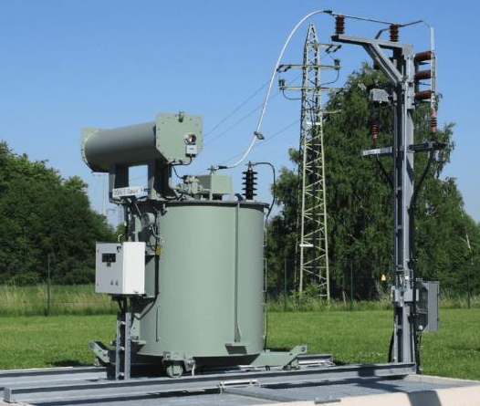

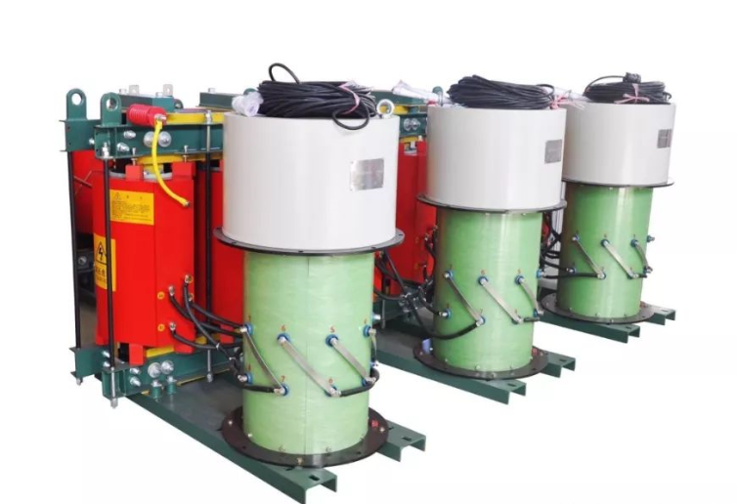

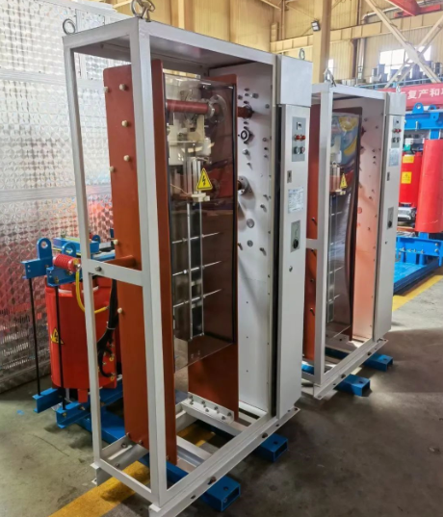

Two, adjustable volume arc suppression coil grounding compensation device Product Introduction: The arc suppressing coil with adjustable volume is a secondary regulating arc suppressing coil, and the arc suppressing coil body is composed of the main winding and the secondary winding. The secondary winding is connected to the capacitance regulating cabinet. When all the secondary capacitors are disconnected, the inductance of the main winding is the smallest and the inductance current is the largest. After the secondary winding is connected with capacitors, according to the impedance conversion principle, it is equivalent to the two ends of the main winding and connected with capacitors of the same power, so that the inductance current of the main winding is reduced. Therefore, the inductive reactance and inductive current of the main winding can be controlled by adjusting the capacity of the secondary capacitance.  
Product features: The capacitor adopts BFMJ film self-healing capacitor with rated working voltage of 1050V, which is equipped with a limited current coil inside or outside to limit the surge current at the closing moment. It is also equipped with discharge resistance. Performance index: Applicable voltage level :6KV, 10KV, 35KV, 66KV Capacity: 100-3800KVAR Operation mode: preset/adjustable Capacitance current measurement error ≤2% Adjustment series ≤64 levels When a single-phase ground fault occurs, the residual current ≤5A The displacement voltage during system operation is less than 10%  
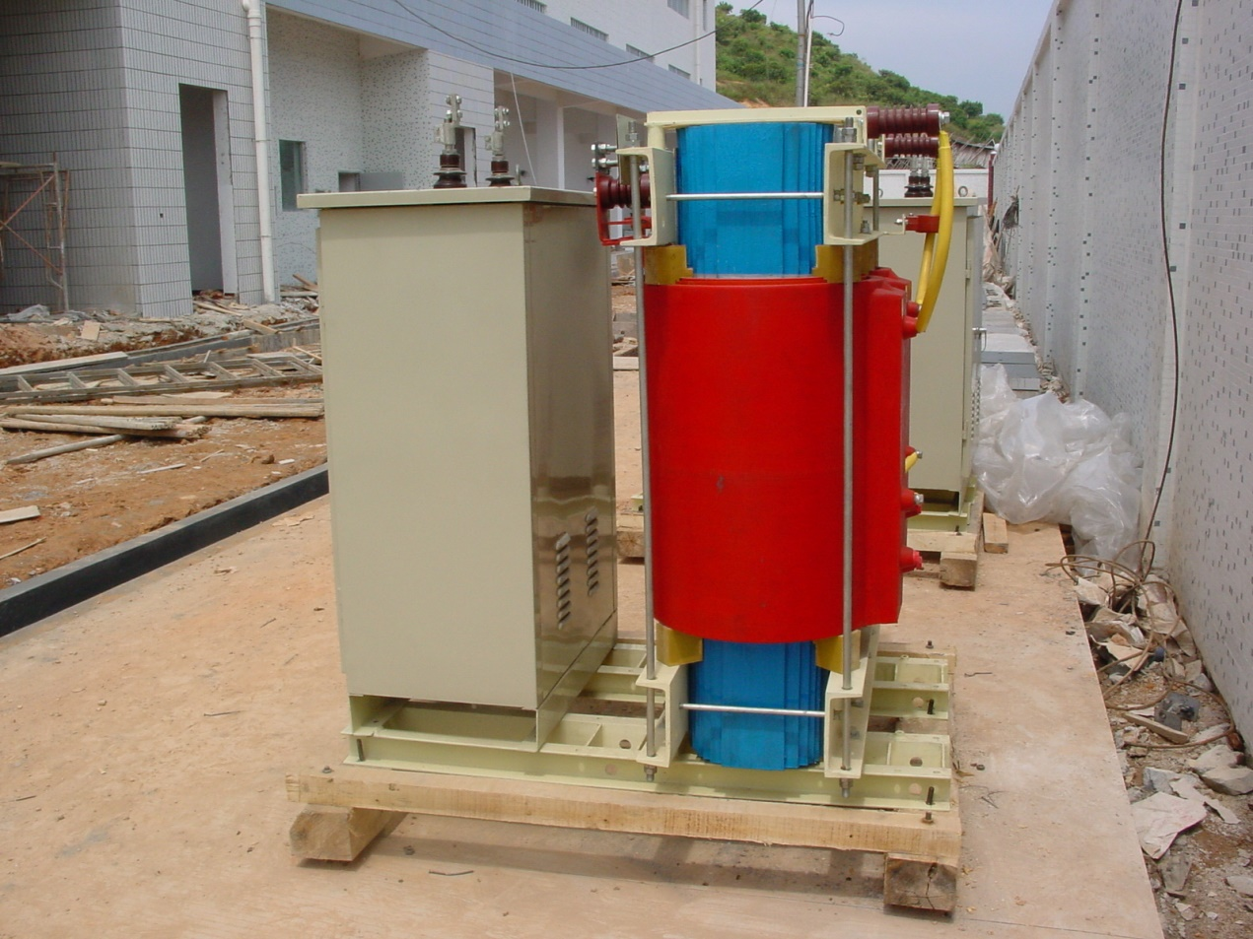

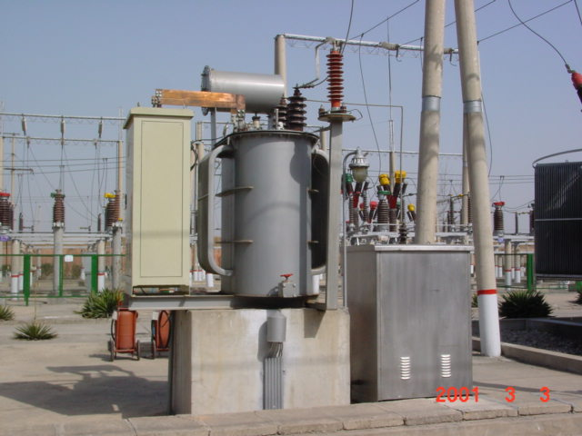

Three, magnetic bias arc suppression coil grounding compensation device Product Introduction: The new magnetic bias fast automatic tracking tuned arc suppression coil is a combination of modern electronic control technology and multistage magnetic saturation technology, and adopts the automatic DC excitation control mode to realize the fast response and continuous adjustment of the arc suppression coil inductance. The inherent contradiction between the ideal goal of full compensation and the unreal grounding caused by series resonance is fundamentally solved. The impedance of the biasing arc suppression coil is very large during the normal operation of the power grid, and the hidden danger of series resonance is completely eliminated without series resistance. The measurement and control system has high precision in measuring the capacitance current of power network. When single-phase grounding occurs in the power grid, the arc suppression coil is adjusted from the high impedance state to full compensation within half a power frequency cycle. Even if the output current of the arc suppression coil is equal to the grounding current, the residual current is minimal.

Product features: The product has large capacity adjustment range, small harmonics (≤ 2%), fast response speed (≤0.01 seconds), high compensation accuracy, no series resonance displacement overvoltage, high reliability, maintenance-free, is the ideal equipment to ensure the safe and reliable operation of the power grid, its technical performance has reached the international advanced level, and is the upgrade product of the existing arc suppression coil. The magnetic bias fast automatic tracking and tuning arc suppression coil technology has reached the international advanced level in terms of performance index, voltage level, capacity and realized functions, and provides effective measures and guarantees for realizing energy saving, consumption reduction and safe and reliable operation of power system  
Performance index: Applicable voltage level :6KV, 10KV, 35KV, 66KV Capacity: 100-3800KVAR Operation mode: preset/adjustable Response time (≤0.01 seconds) Capacitance current measurement error ≤2% When a single-phase ground fault occurs, the residual current ≤5A The displacement voltage during system operation is less than 3%  
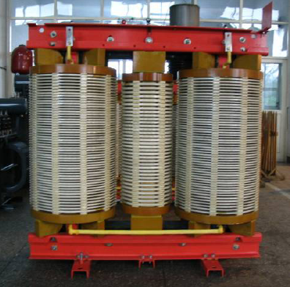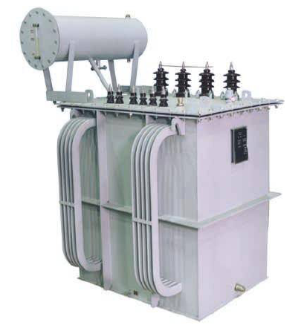

Four, grounding transformer Ground transformer is an inductance device specially used to provide neutral points in power system. (In IEC289, the American AIEE standard No. 32 section 31.1.15 and the national standard GB10229 are required) Its performance characteristics are low zero sequence impedance, high no-load impedance, small no-load loss, and its neutral point can be directly grounded or grounded by resistance or arc elimination coil. To meet the requirements of power system operation or ground fault protection. The ground transformers generally used in the power system are three-phase and the general power transformer is somewhat different, the high voltage side is usually ZN connection, each phase winding is composed of two sections, respectively wrapped around different core columns. Usually can take a secondary winding, composed of ZNyn11 or ZNyn1 group, for the substation station electricity, to play a two-use effect.

